Fault Block Questions

Compression – a stress that squeezes rocks together resulting from forces applied perpendicular to a fault plane

Hanging Wall – a block of crust that lies beneath the fault plane

Hypocenter – the point within the Earth’s crust where an earthquake begins; also commonly termed the focus

Earthquake – the shaking or vibration of the ground surface in response to the sudden release of energy caused by fault movement

Epicenter – the point on the Earth’s surface vertically above the hypocenter

Fault – a fracture in the Earth’s crust where one side moves relative to the other

Fault Plane – the flat (planar) surface along which there is movement during an earthquake

Foot Wall – a block of crust that is located above the fault plane

Normal Fault – a fracture in the Earth’s crust where the hanging wall moves down relative to the footwall

Reverse Fault – a fracture in the Earth’s crust where the hanging wall moves up relative to the footwall

Shear – a stress that moves rock in opposite directions resulting from forces applied parallel to a fault plane

Strike-Slip Fault – a fracture in the Earth’s crust where two blocks of crust move laterally relative to one another

Tectonic Plates – the rigid, thin, irregularly-shaped slabs of solid rock that move relative to one another on the outer surface of the Earth

Tension – a stress that pulls rocks apart resulting from forces applied perpendicular to a fault plane

1. Draw a cross section of a normal fault. Label the following vocabulary terms on your drawing: fault, hanging wall, epicenter, and hypocenter.

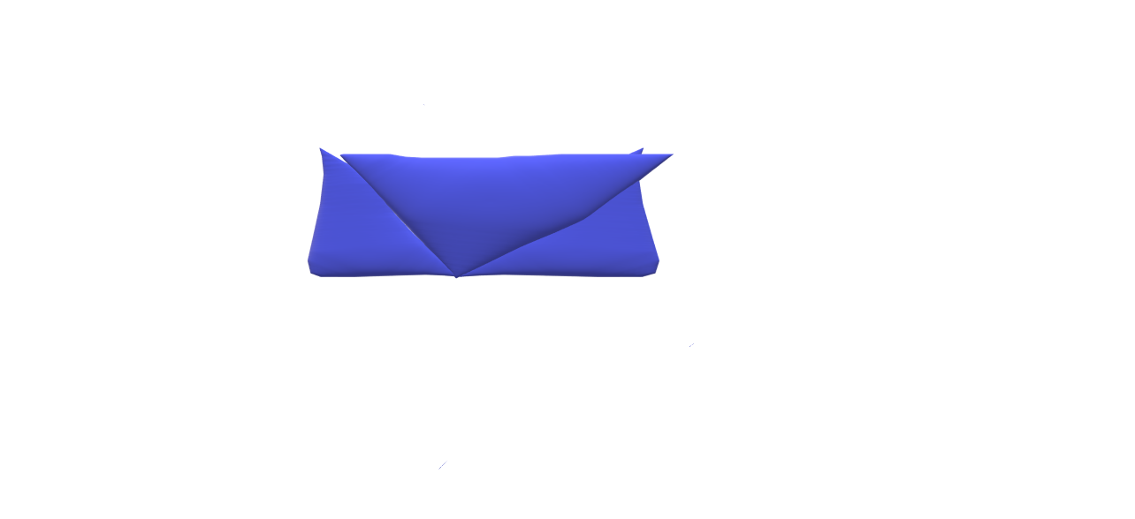

1. What are the three types of faults generated in the Earth's crust? Use vocabulary terms, such as "hanging wall" and "foot wall," to describe each fault. The footwall is on the bottom and the hanging wall is rightish towards the side.
2. Match each type of stress to its corresponding type of fault. Explain your choices.

| Type of stress | Fault produced | Justification |
| --- | --- | --- |
| Compression | Reverse Fault | When compression pushes the hanging wall is pushed up making a reverse fault. |
| Tension | Normal Fault | When the tension pulls the plates away a bunch of normal faults happen causing experiences like valleys. |
| Shear | Strike Slip Fault | The shearing makes the rocks slide past each causing a strike slip fault. |

1. What is the relationship between faults and earthquakes? Faults are caused in different ways by compression, tension, and shearing. Earthquakes are caused by plates and stress building up.